Site 136306
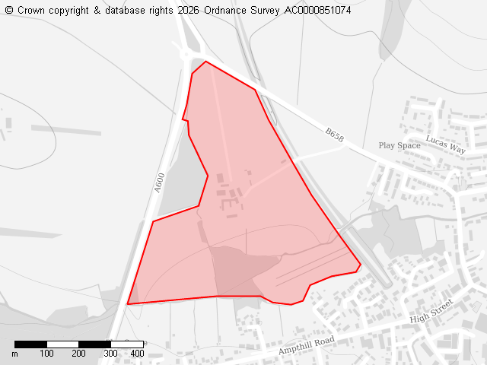

Ward: Shefford
Parish: Shefford
Total Site Size (hectares): 27.58
Proposed Use: Residential

- Part of the land was assessed and rejected for the 2015-2035 Local Plan.
ALP039- Land to rear of 24a Ampthill Road Shefford
Belt 0.38 Site to be excluded from Local Plan process Site fails at Stage 1A. The site is 50% or more within Flood Zones 2 and 3.
- Land off Hazel Close has previously been rejected by CBC.
NLP460: Site is 50% or more within Flood Zones 2 and 3.
- Local Plan Policy SP7 - Windfall Development and Settlement Envelopes.
The site is located beyond the settlement envelope for Shefford. Any development of this magnitude in such a visually exposed location would represent a detrimental and illogical encroachment of substantial built form into the countryside causing unacceptable adverse harm to Shefford’s character and countryside setting. As such, the proposal is contrary to paragraph 170 of the NPPF, and to policies SP7, HQ1, EE3, EE4 and EE5 of our adopted Local Plan (2021).
- Highways Safety and Design.
- Air Pollution.
- NPPF2023 Chapter 2 Achieving Sustainable Development - This site fails to meet this requirement.
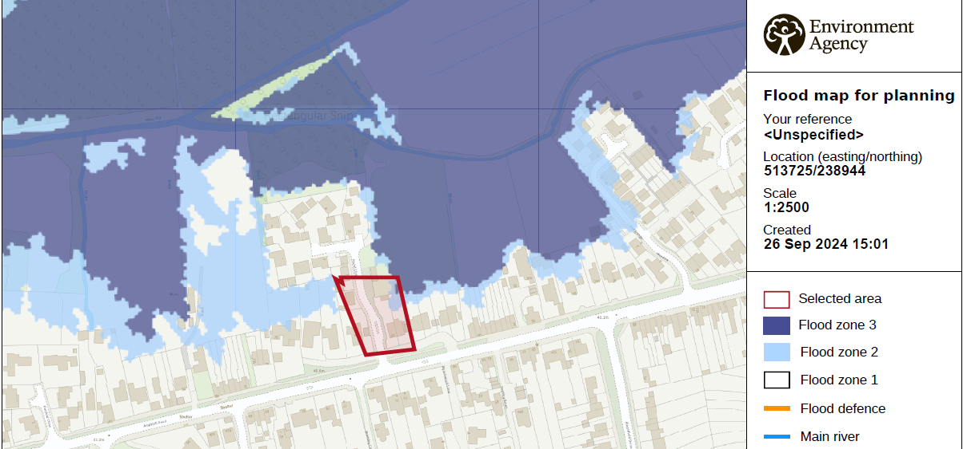
The insufficient health care infrastructure must be addressed before any further residential development is approved in Shefford. Failure to do so risks overwhelming existing facilities and compromising the standard of care available to all residents.
- Flood Risk.
- Best & Most Versatile Land Grades 2 & 3.
Risk to future agriculture
- Contrary to Policy EE5 Landscape Character & Value.
- Coalescent with Chicksands proposed developments.
Shefford’s amenities will suffer.
We object to the proposed allocation of this farmland for development in the Local Plan. The loss of productive agricultural land is irreversible and reduces the area’s ability to support local food production. The development would also place additional pressure on already stretched water resources, increasing the risk of shortages for existing residents and the wider environment. Furthermore, the significant increase in traffic would worsen congestion, road safety, noise, and air quality. Overall, the proposal would result in the unnecessary loss of valuable farmland while placing unsustainable demands on local infrastructure and natural resources. Instead of protecting our green spaces and ensuring our local infrastructure can actually cope, we are facing an unprecedented wave of overdevelopment.

Site 136338

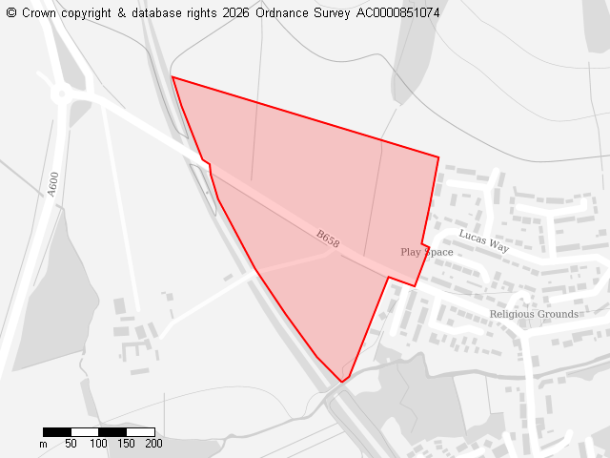
Ward : Shefford
Parish :Shefford
Total Site Size (hectares): 13.21
Proposed Use: Residential

We object to the proposed allocation of this farmland for development in the Local Plan. The loss of productive agricultural land is irreversible and reduces the area’s ability to support local food production. The development would also place additional pressure on already stretched water resources, increasing the risk of shortages for existing residents and the wider environment. Furthermore, the significant increase in traffic would worsen congestion, road safety, noise, and air quality. Overall, the proposal would result in the unnecessary loss of valuable farmland while placing unsustainable demands on local infrastructure and natural resources. Instead of protecting our green spaces and ensuring our local infrastructure can actually cope, we are facing an unprecedented wave of overdevelopment.

The site is located beyond the settlement envelope for Shefford. This significant land parcel in such a visually exposed Greensand Ridge location would represent a detrimental and illogical encroachment of substantial built form into the countryside causing unacceptable adverse harm to Shefford’s character and countryside setting. As such, the proposal is contrary to paragraph 170 of the NPPF, and to policies SP7, HQ1, EE3, EE4 and EE5 of our adopted Local Plan.

- Best & Most Versatile Land Grades 2 & 3.
Where will our crops grow
- Contrary to Policies EE5 Landscape & Value.
- EE8 Greensand Ridge & Nature Improvement Area.
- Co-elescence with Chicksands if proposed sites are permitted.
- Flood risk to homes downstream.
Run-off from roads will overload storm drainage system.
- Could partially be used for green energy.
- Area around farm buildings could be affordable housing / industrial units/ luxury barn conversion.
- Flood risk
Cricket Bat Willow

Site 136428
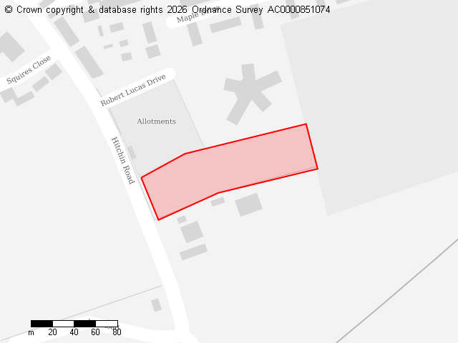
Ward: Shefford
Parish: Shefford
Total Site Size (hectares): 0.68
Proposed Use: Residential
Location: Hitchin Road

Positive Comment:

- Could consider this is the community choice for building affordable homes

Objections:

We object to the proposed allocation of this land for development in the Local Plan. The development would also place additional pressure on already stretched water resources, increasing the risk of shortages for existing residents and the wider environment. Furthermore, the significant increase in traffic would worsen congestion, road safety, noise, and air quality. Overall, the proposal would result in the unnecessary loss of valuable farmland while placing unsustainable demands on local infrastructure and natural resources. Also, instead of protecting our green spaces and ensuring our local infrastructure can actually cope, we are facing an unprecedented wave of overdevelopment.

National Planning Policy Framework (NPPF)and Local Plan Policy SP7 - Windfall Development and Settlement Envelopes
- Best & Most Versatile Land Grade 2.
The land proposed for development is BMV land Grade 2, which is offered protection within NPPF2024.
It has been repeatedly claimed that as Bedfordshire has a lot of BMV land it is inevitable that some must be lost to development. However, the country does not have such a predominance of BMV land. As stated, development of this BMV Grade 2 site is clearly not necessary or sustainable. It is now even more important to ensure the country’s food security and protect our most productive agricultural land – which is a diminishing resource.
- Risk to existing Wildlife

Impact on Landscape Character and Policy EE5 Compliance
Central Bedfordshire Council recognises the intrinsic beauty of the countryside.
- Local Policy TP1 Mitigation of Transport Impacts on the Network
- Local Policy T2 Highways Safety and Design
Hitchin Road will be impacted and A507 is already up to capacity
- Sustainability
The insufficient health care infrastructure must be addressed before any further residential development is approved in Shefford. Failure to do so risks overwhelming existing facilities and compromising the standard of care available to all residents.
- Lack of Infrastructure – Wastewater
At present, Clifton WRC lacks sufficient capacity to accommodate the additional wastewater flows that would be generated by this development.

Site 136431
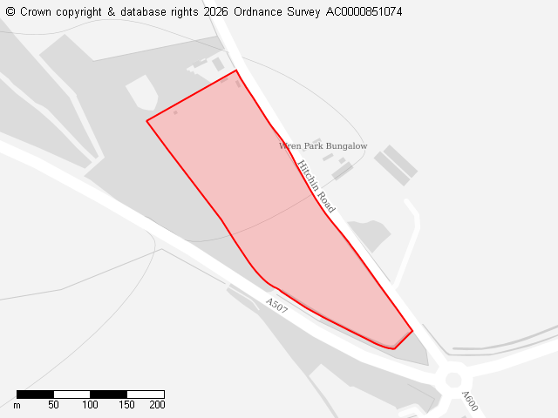
Ward: Shefford
Parish: Shefford
Total Site Size (hectares): 4.84
Proposed Use: Employment

We object to the proposed allocation of this farmland for development in the Local Plan. The loss of productive agricultural land is irreversible and reduces the area’s ability to support local food production. The development would also place additional pressure on already stretched water resources, increasing the risk of shortages for existing residents and the wider environment. Furthermore, the significant increase in traffic would worsen congestion, road safety, noise, and air quality. Overall, the proposal would result in the unnecessary loss of valuable farmland while placing unsustainable demands on local infrastructure and natural resources. Instead of protecting our green spaces and ensuring our local infrastructure can actually cope, we are facing an unprecedented wave of overdevelopment.

- Coelescent of Shefford with Meppershall and Campton if nearby proposed sites are permitted.
- Best & Most Versatile Land Grade 1.
Where will our crops grow?
- Risk to existing Wildlife

National Planning Policy Framework (NPPF)and Local Plan Policy SP7 - Windfall Development and Settlement Envelopes

The proposed development is situated outside the settlement envelope of the village, placing it entirely within open countryside

Impact on Landscape Character and Policy EE5 Compliance
Outside settlement envelopes, the Council recognises the intrinsic beauty of the countryside.
- Local Policy TP1 Mitigation of Transport Impacts on the Network
- Local Policy T2 Highways Safety and Design
A507 is already at capacity.
Air pollution caused by traffic is second worst in the area.
Sustainability
The insufficient health care infrastructure must be addressed before any further residential development is approved in Shefford. Failure to do so risks overwhelming existing facilities and compromising the standard of care available to all residents.
- Lack of Infrastructure – Wastewater
At present, Clifton WRC lacks sufficient capacity to accommodate the additional wastewater flows that would be generated by this development.
Previously rejected by Local Plan consultation:

NLP009 Land at Hitchin Road, Shefford (west) Shefford Shefford Not GreenBelt 4.38 Site to be excluded from Local Plan process Site fails at Stage 1B. The site is poorly related to Shefford and detached from the settlement.

Site 136591
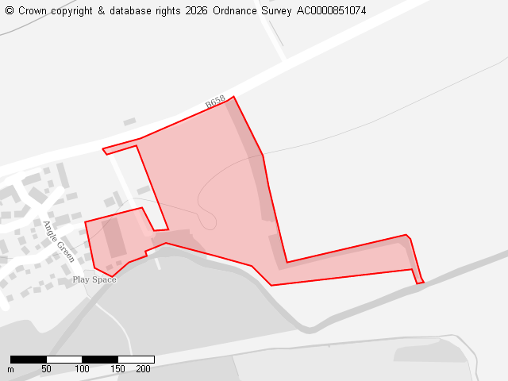
Ward: Shefford
Parish: Shefford
Total Site Size (hectares): 4.63
Proposed Use: Residential

We object to the proposed allocation of this farmland for development in the Local Plan. The loss of productive agricultural land is irreversible and reduces the area’s ability to support local food production. The development would also place additional pressure on already stretched water resources, increasing the risk of shortages for existing residents and the wider environment. Furthermore, the significant increase in traffic would worsen congestion, road safety, noise, and air quality. Overall, the proposal would result in the unnecessary loss of valuable farmland while placing unsustainable demands on local infrastructure and natural resources. Instead of protecting our green spaces and ensuring our local infrastructure can actually cope, we are facing an unprecedented wave of overdevelopment.
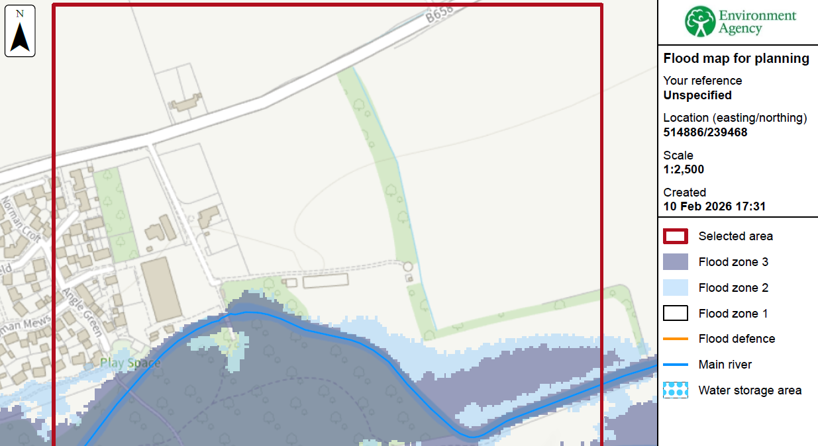
- Best & Most Versatile Land Grade 1.
Where will our crops grow?
- Flood Risk - see map
- Risk to existing Wildlife
Migratory route for several species of bat as per Ecology report undertaken 2025

National Planning Policy Framework (NPPF)and Local Plan Policy SP7 - Windfall Development and Settlement Envelopes

The proposed development is situated outside the settlement envelope of the village, placing it entirely within open countryside

Impact on Landscape Character and Policy EE5 Compliance
Outside settlement envelopes, the Council recognises the intrinsic beauty of the countryside.
- Local Policy TP1 Mitigation of Transport Impacts on the Network
- Local Policy T2 Highways Safety and Design
Stanford Road will not cope
- Sustainability
The insufficient health care infrastructure must be addressed before any further residential development is approved in Shefford. Failure to do so risks overwhelming existing facilities and compromising the standard of care available to all residents.
- Lack of Infrastructure – Wastewater
At present, Clifton WRC lacks sufficient capacity to accommodate the additional wastewater flows that would be generated by this development.
- CHECK correct siteRejected on 2017 Local Plan:

- CHECK correct siteRejected on 2017 Local Plan:
NLP155 Land to the South of Shefford Shefford Not Green 4.60 NLP389 Site to be excluded from Fails at Stage 2 based on an overall consideration using planning balance. The following Stanford Rd Shefford Belt Local Plan process issues have been identified: the main issue being the sites relationship and impact on the character of Shefford. The site is separated from Shefford in the south by the Ivel River and although the area to the west adjoins Shefford settlement, this area has dispersed buildings and thus development here would have an impact on the more rural nature of Shefford here.

Site 136617
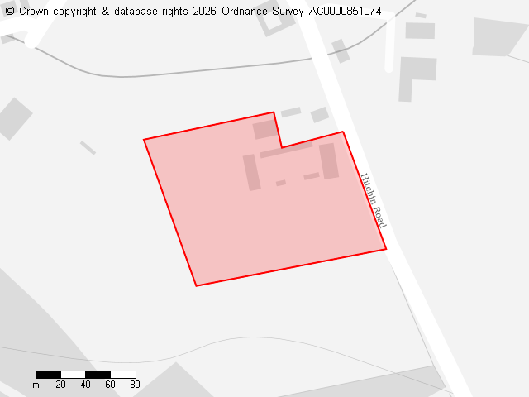
Ward:Shefford
Parish:Shefford
Total Site Size (hectares):1.78
Proposed Use:Residential

We object to the proposed allocation of this farmland for development in the Local Plan. The loss of productive agricultural land is irreversible and reduces the area’s ability to support local food production. The development would also place additional pressure on already stretched water resources, increasing the risk of shortages for existing residents and the wider environment. Furthermore, the significant increase in traffic would worsen congestion, road safety, noise, and air quality. Overall, the proposal would result in the unnecessary loss of valuable farmland while placing unsustainable demands on local infrastructure and natural resources. Instead of protecting our green spaces and ensuring our local infrastructure can actually cope, we are facing an unprecedented wave of overdevelopment.

- The site is located beyond the settlement envelope for Shefford and has previously been submitted as a windfall site and refused by the Council in 2022. A development of this potential size in such a visually exposed location would represent a detrimental and illogical encroachment of substantial built form into the countryside causing unacceptable adverse harm to Shefford’s character and countryside setting. As such, the proposal is contrary to paragraph 170 of the NPPF, and to policies SP7, HQ1, EE3, EE4 and EE5 of the Central Bedfordshire Local Plan (2021). This site is categorised as Best & Most Versatile Land Grade 2.

- Any access at this location would lead to danger and inconvenience to future residents using it and to highway users in general and be contrary to Policy T2 of the current adopted Plan.

- Possible site for recreational use - eg Shefford Saints football club / Scouts

- Check drainage -teasels on land

Site 136720
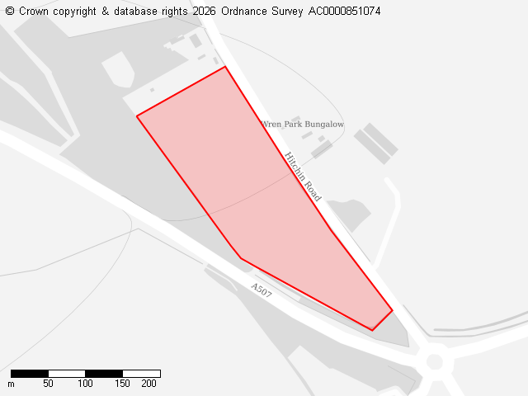
Ward:Shefford
Parish: Shefford
Total Site Size (hectares):4.29
Proposed Use: Employment, Green energy

- Coelescent of Shefford with Meppershall and Campton if nearby proposed sites are permitted.

- Best & Most Versatile Land Grade 1.
Where will our crops grow?

- Risk to existing Wildlife

National Planning Policy Framework (NPPF)and Local Plan Policy SP7 - Windfall Development and Settlement Envelopes

The proposed development is situated outside the settlement envelope of the village, placing it entirely within open countryside

Impact on Landscape Character and Policy EE5 Compliance
Outside settlement envelopes, the Council recognises the intrinsic beauty of the countryside.
- Local Policy TP1 Mitigation of Transport Impacts on the Network
- Local Policy T2 Highways Safety and Design
A507 is already at capacity.
Air pollution caused by traffic is second worst in the area.
Sustainability
The insufficient health care infrastructure must be addressed before any further residential development is approved in Shefford. Failure to do so risks overwhelming existing facilities and compromising the standard of care available to all residents.
- Lack of Infrastructure – Wastewater
At present, Clifton WRC lacks sufficient capacity to accommodate the additional wastewater flows that would be generated by this development.
Previously rejected by Local Plan consultation:

Site 136431
Ward:Shefford
Parish: Shefford
Total Site Size (hectares):4.29
Proposed Use:Residential,Employment, Green energy

We object to the proposed allocation of this farmland for development in the Local Plan. The loss of productive agricultural land is irreversible and reduces the area’s ability to support local food production. The development would also place additional pressure on already stretched water resources, increasing the risk of shortages for existing residents and the wider environment. Furthermore, the significant increase in traffic would worsen congestion, road safety, noise, and air quality. Overall, the proposal would result in the unnecessary loss of valuable farmland while placing unsustainable demands on local infrastructure and natural resources. Instead of protecting our green spaces and ensuring our local infrastructure can actually cope, we are facing an unprecedented wave of overdevelopment.

- Co-elesent of Shefford with Meppershall and Campton if nearby proposed sites are permitted.
- Best & Most Versatile Land Grade 1.
Where will our crops grow?
- Risk to existing Wildlife

National Planning Policy Framework (NPPF)and Local Plan Policy SP7 - Windfall Development and Settlement Envelopes

The proposed development is situated outside the settlement envelope of the village, placing it entirely within open countryside

Impact on Landscape Character and Policy EE5 Compliance
Outside settlement envelopes, the Council recognises the intrinsic beauty of the countryside.
- Local Policy TP1 Mitigation of Transport Impacts on the Network
- Local Policy T2 Highways Safety and Design
A507 is already at capacity.
Air pollution caused by traffic is second worst in the area.
Sustainability
The insufficient health care infrastructure must be addressed before any further residential development is approved in Shefford. Failure to do so risks overwhelming existing facilities and compromising the standard of care available to all residents.
- Lack of Infrastructure – Wastewater
At present, Clifton WRC lacks sufficient capacity to accommodate the additional wastewater flows that would be generated by this development.
Previously rejected by Local Plan consultation:

Site 136946
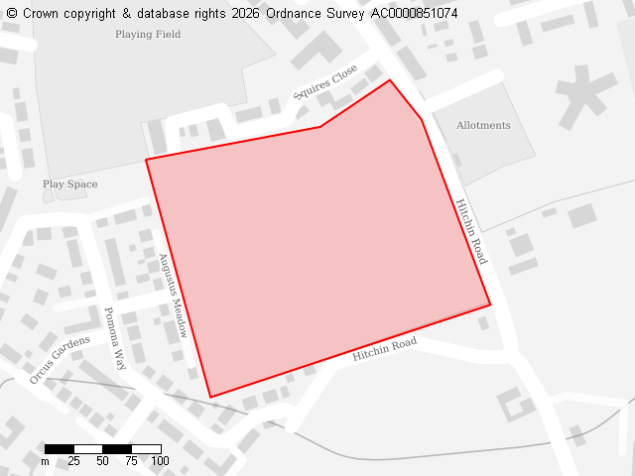
Ward:Shefford
Parish:Shefford
Total Site Size (hectares):4.95
Proposed Use:Residential

- This site was originally earmarked as a location for a new school. Over the past 10 years, the population of Shefford has risen dramatically and schools are currently at maximum capacity despite CBC saying the decreasing population reduces the need for additional schools.
- Could be a site for affordable residential homes.

We object to the proposed allocation of this land for development in the Local Plan as it was originally earmarked as a location for a new school. Over the past 10 years, the population of Shefford has risen dramatically and schools are currently at maximum capacity.

The development would also place additional pressure on already stretched water resources, increasing the risk of shortages for existing residents and the wider environment. Furthermore, the significant increase in traffic would worsen congestion, road safety, noise, and air quality.

Overall, the proposal would result in the unnecessary loss of valuable farmland while placing unsustainable demands on local infrastructure and natural resources. Instead of protecting our green spaces and ensuring our local infrastructure can actually cope, we are facing an unprecedented wave of overdevelopment.

The development would also place additional pressure on already stretched water resources, increasing the risk of shortages for existing residents and the wider environment. Furthermore, the significant increase in traffic would worsen congestion, road safety, noise, and air quality. Overall, the proposal would result in the unnecessary loss of valuable farmland while placing unsustainable demands on local infrastructure and natural resources. Instead of protecting our green spaces and ensuring our local infrastructure can actually cope, we are facing an unprecedented wave of overdevelopment.

