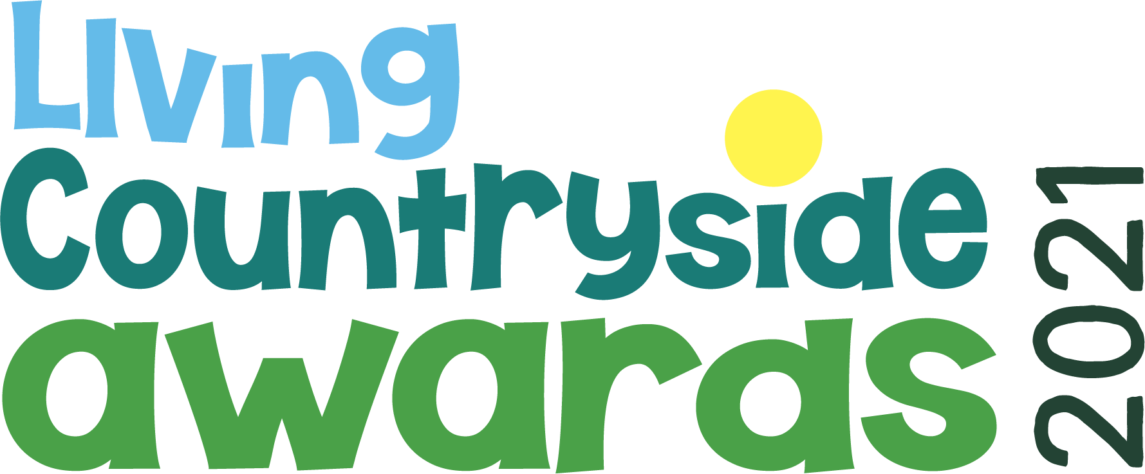

Living Countryside Awards 2021 – Nomination Form

General guidance

Previous nominees (including award winners) are welcome to reapply but should clearly show how they have progressed or developed since their last application.

Projects should fall, or have a significant impact, within the county of Bedfordshire.

You may nominate your own project or one you know of but please get the project managers permission first

Projects can take any form, including businesses, charities, voluntary or community groups, schools, clubs and individuals.

We may use submitted photographs and quotes from your written material on our website and social media channels to help promote the awards. By submitting your form you are agreeing to CPRE Bedfordshire using your information in this way. Personal email addresses and other contact details will not be made public. If you have any questions about how we will use the information you submit please contact awards@cprebeds.org.uk

Finalists will be filmed as part of the process.

Which category are you entering?
Please see cprebeds.org.uk/discover/2021awards/ for further information about the categories.

Better Places to Live
Connecting People and Countryside
Made in Bedfordshire
Inspiring Young People

Name of project

Project address

Project website and / or social media accounts

Name and contact details of person making application (address, email, phone number)

Name and contact details of the project co-ordinator (if different to above)

Name and contact details of land owner or property owner (if applicable)

Project description (300 words max) Your description should show how your project meets the criteria for your category.

How is your project making a positive difference in your community or beyond? (300 words max)

What challenges did you face during the lockdowns and covid-19 restrictions of 2020/1? How did you overcome them and how have they changed your project? (300 words max)

Supporting material – e.g. photographs, video, drawings, plans
Any additional material you wish to provide can be uploaded. Please follow the on screen guidance on maximum file sizes and file types.

We are planning on offering workshops and networking session to all nominees. What topics would be of interest to you? What knowledge or expertise would you be willing to share with others?

